1. **Outlier Treatments**

Instructions:

Please share your answers filled inline in the word document. Submit Python code and R code files wherever applicable as Python File (.py) and R file as .r extension files.

Please ensure you update all the details:

**Name: Avishek kumar verma**

**Batch Id: 05012021_10A.M**

**Topic: Preliminaries for Data Analysis**

**Problem Statement:**

Most of the datasets have extreme values or exceptions in their observations. These values affect the predictions (Accuracy) of the model in one way or the other, removing these values is not a very good option. For these types of scenarios, we have the techniques for treating such values. Explore on various other techniques to treat these values, you can go through this link:

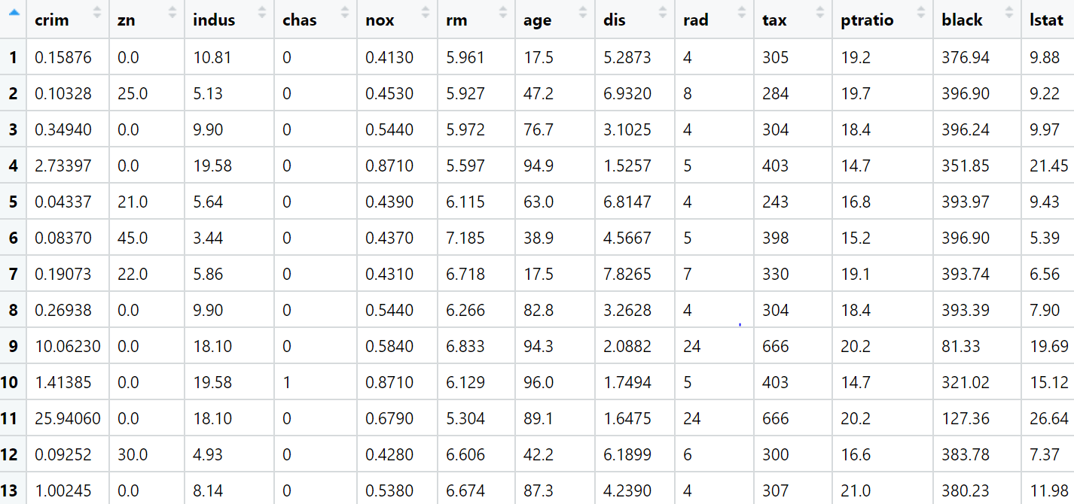

**Ans:-**

**Data types: -**

|  |  |  |  |
| --- | --- | --- | --- |
| **Name of features** | **Description** | **Type** | **Relevance** |
| crime | Crime | Ratio | Relevant |
| zn | zn | Ratio | Relevant |
| Indus | Indus | Ratio | Relevant |
| nox | nox | Ratio | Relevant |
| rm | rm | Ratio | Relevant |
| age | age | Ratio | Relevant |
| dis | dis | Ratio | Relevant |
| rad | rad | Count | Relevant |
| tax | tax | Ratio | Relevant |